DOCUMENT 25 — Security Architecture & Threat Model
Visionary Internal · v1.0 · Trust boundaries over the VATS/AIRA surface

Security properties are architecture, not policy. Every control below is enforced in
code and verified by contract tests (Doc 08 KF2) and sampled audits.

1. Threat model (STRIDE-mapped to assets)

Asset | Threat | Control
SCM state | Tampering / repudiation | append-only L7 writes, signed service tokens, audit log
Memory (Qdrant) | Information disclosure | per-student namespace, per-student KMS key, server-side RBAC
L7 events | PII leakage | scrub before ingest (Doc 24 KF3), sampled audit
Billing / entitlements | Tampering | server-side entitlement check on every render, Razorpay webhook signature verify
Consent (parent/teacher/org) | Spoofing / elevation | verifiable parental consent, OTP-bound roles, expiry + revoke cascade
Model registry | Supply-chain | signed artifacts, MLflow gate, canary 5%→100% (Doc 10)
Public API | DoS / abuse | rate-limit + WAF at gateway, per-role quotas
Session | Hijack | short-lived tokens, device binding, refresh rotation

2. Trust boundaries
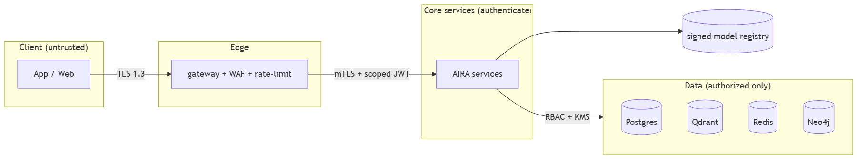

3. Program controls
Secrets in managed vault, rotation ≤90d · dependency + container scanning in CI ·
pen-test before each public phase · incident runbook with DPDP breach-notification
timelines · SIEM anomaly alerts on cross-role read attempts · bug bounty post-Series-A.

OKF
KF1 zero server-trusted client claims (entitlements/RBAC server-side) · KF2 cross-role read
attempt alerts in ≤5 min · KF3 100% registry artifacts signed · KF4 pen-test findings
critical/high closed before next phase · KF5 breach runbook drilled quarterly.

